Coach Jordan's Motion Offense
Notice: This article was written by Steve Jordan, Coach's Notebook. Email the author at sjordan@alaskalife.net. http://www.akcoach.com/

Motion Offense in Four Easy Steps
This is a very straight forward motion based offense that you can use with experienced teams that have good basic skills and understand pick and roll, give and go concepts, and also have post players that have fairly versatile skills. This is not a beginner offense! Just because the pattern is simple doesn't guarantee success. What the play provides is a means to organize your player's movements into expected behaviors and still allow some independent decision making.
This offense is best used against a man to man defense. However, if your opponent extends a zone and tries to pressure the wings, all the give and go, pick and roll elements can work.
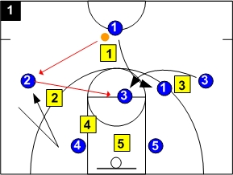
Diagram 1
That part in the title about "Easy" steps? I was just kidding about that. This is a simple play, but if your players are not fundamentally sound in their ball handling and passing skills, or they cannot read the defensive actions very well, you will struggle with this offense.
My motion offense starts when the ball gets to the wing. In the drawing, B1 is passing to B2. If the point, B1, does something different like try to penetrate, that is not our offense. One of the discipline areas to emphasize is for the players to follow the play as shown. Otherwise, there will be confusion as they are dealing with innovation all the time. The motion offense offers plenty of options as it is without creating new movements that are not expected.
OK, the pass goes to the wing. To make this succeed, you must teach your wings to get open. An easy way is for the wing to literally walk towards the post, B4, then suddenly jump back to the wing spot. The quick change of direction will provide enough space for a pass. Your wings can also curl around the post players or even go baseline and exchange places with each other. Another option is for the wing to screen low for the post and let the post move to the wing spot. See? There are lots of options just throwing the basketball from B1 to B2. Pick one or two "get open" moves to perfect and stick with them.
After the pass to B2, B1 picks away for B3. B3 sheds his man on the screen and looks for a pass from B2 and hopefully gets an open shot.
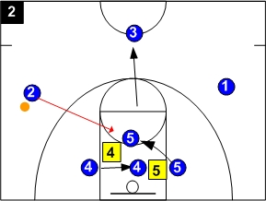
Diagram 2
B3 did not get the ball so he moves out to the point position.
B4 posts up looking for a pass. If the defense plays behind B4, B2 throws the ball inside to B4 and cuts to the basket. B4 can either handoff or make his own move to the basket. (This option is not drawn at the left)
If B4 doesn't get the ball in a two-count (two seconds), he breaks across the key and screens for B5. B5 uses the screen to get free and cuts on the high side of the screen to get a pass from B2. This move is drawn at the left and it is the opening that we get most often.
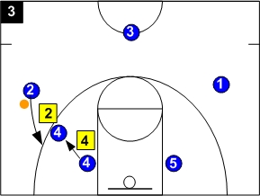
Diagram 3
Another option for the post man B4 is to set up a pick and roll for B2. After the two count, instead of rolling and screening for B5, B4 moves out and establishes a screen for B2. We usually signal this by having the wing call for a pick. If B2 is effective in making the defender run into the screen, a short jumper will be available or he can pass to the rolling B4 post.
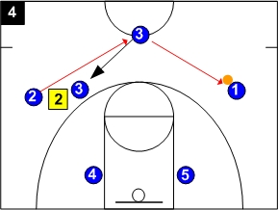
Diagram 4
If none of the described options work out, B2 can pass the ball back to the point position, now B3. Make sure your wing players take a good look inside every time they get the ball because that's where the offense starts. If the wing immediately returns the ball to the point, the offense never gets started at all.
Conversely, the point position's job is to quickly rotate the ball to the other wing so the offense can start over there. If your point holds the ball or gets creative, your offense stalls out.
Once the point (B3 here) passes to the other wing, he needs to pick away for B2. At this moment you can refer back to diagram 1 because the entire process repeats itself from the other side of the floor. B1 will now go through the various options working with B5.

