Out of bounds b
Playname : Baseline out of bounds 33
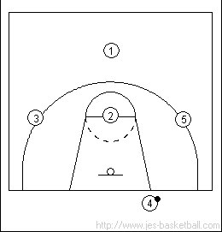 | 1  CROSS  This is our initial set up for "cross"  2 can be a left-hander  1 can be a right-hander
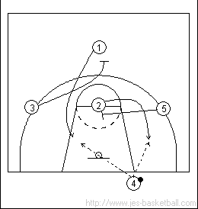 | 2  On the ball slap or call, 3 & 5 will set simultaneous screens on the defenders of 1 & 2.  1 will cut hard to the basket looking for the inbounds pass from 4 this is our first look.  2 will cut hard to the ball looking for the inbounds from 4 & a quick shot.
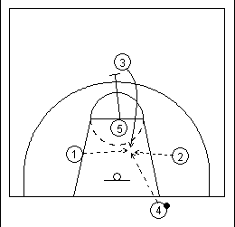 | 3  If 4 were to inbound the ball to either cutters, he would enter the court opposite of the direction he threw his pass. He should look to post up whichever direction he goes in case his defender leaves him to stop the cutter.  After 5 has set his screen for 2, he should immediately go set a screen for 3 who had previously set a screen for 1. This action is known as "picking the picker".  3 would cut to the basket hard looking for an offensive rebound or a pass from 4 out of bounds or 1 or 2 if the ball has already been in bounded to one of them.

